ISEV2018
www.isev2018.cn
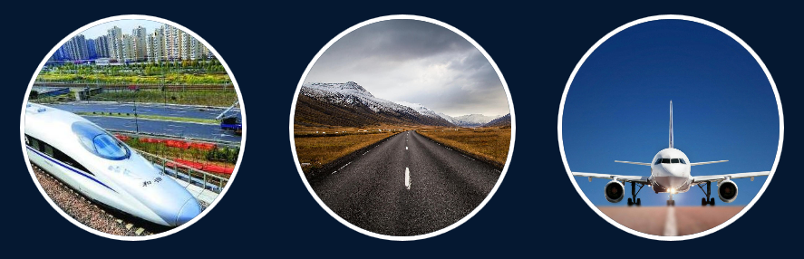

26-28 October 2018 Changsha, China

8th International Symposium on Environmental
Vibration and Transportation Geodynamics
&
2nd Young Transportation Geotechnics Engineers
(YTGE) Meeting
Under the auspices of ISSMGE-TC202 Transportation Geotechnics

Organizer:
Sponsors:

Co-sponsors:
Central South University
ISSMGE TC202 (Transportation Geotechnics)
Chinese Society of Civil Engineers
(To be added)

Zhantianyou Development Foundation for Science & Technology
China Construction Fifth Engineering Division Corp. Ltd.
Hunan Zhongda Design Institute Co. Ltd.
Office of International Cooperation & Exchanges, CSU
School of Civil Engineering, CSU
(To be added)

Contents
Welcome 1
Key Dates 3
Committees 3
Scientific Committee 3
Organizing Committee 6
Practical Information 9

Welcome
The 8th International Symposium on Environmental Vibration and Transportation Geodynamics (formerly named as the International Symposium on Environmental Vibration) will be held on October 27-28, 2018 at Central South University, Changsha, China. In 2003, the first symposium was initiated by H. Takemiya of Okayama University, Japan and Yunmin Chen of Zhejiang University, China, and held in Zhejiang University, Hangzhou, China. The subsequent six symposia were successfully convened in Okayama University, Japan (2005), National Taiwan University, Taipei (2007), Beijing Jiaotong University, China (2009), Southwest Jiaotong University, China (2011), Tongji University, China (2013), and Zhejiang University, China (2016), respectively. With the increasing impact over academia and industry, the symposia have attracted much attention from government officials, scientific and research communities, and engineering professionals. Geotechnical challenges associated with dynamic loads on railroad track and road pavements often require scientific and technological breakthroughs for design innovations. To effectively reflect such frontiers, this symposium has been renamed as International Symposium on Environmental Vibration and Transportation Geodynamics since 2016, and held under the auspices of the International Society for Soil Mechanics and Geotechnical Engineering (ISSMGE) TC202 Transportation Geotechnics Committee.
The scope of the 8th International Symposium on Environmental Vibration and Transportation Geodynamics 2018 (ISEV 2018) will continue to cover environmental vibrations induced by industrial, civilian and transportation activities, problems associated with dynamic vehicular loading on road foundations, and sustainability challenges of transportation infrastructures and the built environment. The symposium will consist of workshops (including one dedicated to Young Transportation Geotechnics Engineers) and plenary and breakout sessions as well as a technical exhibition for dissemination of research findings and engineering best practices. The ISEV 2018 event will serve as a significant platform for academic exploration, experience exchange, and thought inspiration amongst the practitioners engaged in management, design and construction of large-scale civil and transportation infrastructure, researchers, academics and students. Engineers from planning, design construction and management engineering companies, decision makers, transport infrastructures managers and owners, and governmental bodies are especially encouraged to attend this symposium.
Associated with the ISEV 2018 event, the 2nd Young Transportation Geotechnics Engineers (YTGE) meeting will be concurrently held on October 26, 2018. The 1st meeting of the YTGE associated with the 3rd International Conference on Transportation Geotechnics (ICTG) was successfully convened at University of Minho, Guimarães, Portugal on September 4, 2016. This forum was organized and hosted by students at the University of Minho with student participation from all around the world. It covered all the disciplines in transportation geotechnics (roads, highways, bridges, airports, railways, waterways, canals and terminals- harbors). For the first time, it created a knowledge exchange network and compiled what the best and most advanced practices worldwide in the transportation geotechnics field are either in academic or in industrial domains.
The YTGE network will be created in the framework of the ISEV 2018 event and will be held in Changsha, China on October 26, 2018. The main goal of this forum will be to increase the attractiveness of the transportation geotechnics field for younger generations of engineers (less than 35 years old), whilst contributing to strengthen the role of young engineers in society. The network will be responsible for organizing several initiatives for the young geotechnical community. The aims are to provide an international forum for doctoral and post-doctoral students as well as research engineers and engineers involved in innovation in transportation geotechnics, to present and discuss their main research results, and to identify future research and engineering practice needs. Relevant work related to all disciplines in transportation geotechnics are sought out for the 2nd YTGE meeting in the form of a two-page extended abstract and workshop presentation. All submissions (extended abstract and presentation) will be compiled into a USB drive and made available to all YTGE members.
We are pleased to invite you to be part of the ISEV 2018 event and 2nd YTGE meeting.
We look forward to welcoming you to Changsha in October 2018.
  Erol Tutumluer  Chair of the Conference | 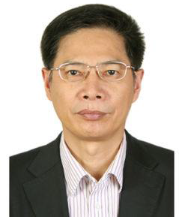  Zhiwu Yu  Co-Chair of the Conference

Key Dates
Deadline for Abstract submission January 31, 2018
Notify authors of accepted abstracts February 21, 2018
Deadline for Full-length paper submission May 31, 2018
Notify authors of accepted papers August 31, 2018
Submission of final camera-ready papers September 15, 2018

Committees

Scientific Committee
Honorary Chairmen (in Alphabetic Order of Last Name)
Yunmin Chen | Zhejiang University, China
Guangyun Gao | Tongji University, China
Huawu He | China Railway Group Corporation, China
Hongqi Tian | Central South University, China
Yeongbin Yang | Chongqing University, China
Wanming Zhai | Southwest Jiaotong University, China
Chairmen
Erol Tutumluer | University of Illinois at Urbana-Champaign
Zhiwu Yu | Central South University
Members （To be added, in Alphabetic Order of Last Name）
Lutz Auersch | Federal Institute for Materials Research and Testing, Germany
Dimitri E. Beskos | University of Patras, Greece
Yuanqiang Cai | Zhejiang University, China
Jinchun Chai | Saga University, Japan
Renpeng Chen | Hunan University, China
Xiangsheng Chen | Shenzhen Metro, China
António Gomes Correia | University of Minho, Portugal
Yujun Cui | Ecole des Ponts Paris Tech, France
Geert Degrande | University of Leuven, Belgium
Liang Gao | Beijing Jiaotong University, China
Guangyun Gao | Tongji University, China
Jie Han | University of Kansas, USA
Toshiki Hamamoto | University of Toyama, Japan
Hong Hao | Curtin University of Cambridge, UK
Kimitoshi Hayano | Yokohama National University
Xia He | Beijing Jiao Tong University, China
Carlton Ho | University of Massachusetts, Amherst, USA
XiangChen Hou | Harbin Institute of Technology, China
Baoshan Huang | University of Tennessee, USA
Maosong Huang | Tongji University, China
Hai Huang | Pennsylvania State University, USA
Hugh Hunt | University of Cambridge, UK
Buddhima Indraratna | University of Wollongong, Australia
Tatsuya Ishikawa | Hokkaido University, Japan
Jianqun Jiang | Zhejiang University, China
Shenghao Ju | National Cheng-Kung University, Tainan
Xiaoyan Lei | East China Jiaotong University, China
Dingqing Li | TTCI, USA
Yongle Li | Southwest Jiao Tong University, China
Suched Likitlersuang | Chulalongkorn University, Thailand
Xianzhang Ling | Harbin Institute of Technology, China
Jiankun Liu | Beijing Jiao Tong University, China
Songyu Liu | Southeast University, China
Qiang Luo | Southwest Jiao Tong University
Andrei V. Metrikine | Delft University of Technology, Netherlands
Yoshitsugu Momoya | Railway Technical Research Institute, Japan
Soheil Nazarian | University of Texas at El Paso, USA
Takashi Okayasu | Kyushu University, Japan
Jin Y Ooi | The University of Edinburgh, UK
Taesoon Park | Seoul National University of Science & Technology, South Korea
Yonglin Pi | The University of New South Wales, Australia
William Powrie | University of Southampton, UK
Anand Puppala | University of Texas at Arlington, USA
Imad L. Al-Qadi | University of Illinois at Urbana-Champaign, USA
Yu Qian | University of South Carolina, USA
Tong Qiu | Pennsylvania State University, USA
Yanjun Qiu | Southwest Jiao Tong University
Jiping Ru | Natural Science Foundation of China, China
Charles Schwartz | University of Maryland, College Park, USA
Daichao Sheng | University of New Castle, Australia
Ted Sussmann | University of Hartford, USA
Yiqiu Tan | Harbin Institute of Technology, China
Tawatchai Tanchaisawat | Chiang Mai University, Thailand
Fumio Tatsuoka | Tokyo University of Science, Japan
Erol Tutumluer | University of Illinois at Urbana-Champaign, USA
Fuming Wang | Zhengzhou University, China
Hainian Wang | Changan University
Hao Wang | Rutgers University
Linbing Wang | Virginia Polytechnic Institute and State University, USA
Ping Wang | Southwest Jiaotong University, China
Peter Woodward | University of Leeds, UK
He Xia | Beijing Jiaotong University, China
Weiping Xie | Wuhan University of Technology, China
Bin Xu | Nanchang Institute of Nottingham, UK
Youlin Xu | The Hong Kong Polytechnic University, HK
Jun Yang | The University of Hong Kong, HK
Yangping Yao | Beihang University, China
Jongdar Yau | Tamkang University, Taipei
Zhanping You | Michigan Tech, USA
Haisui Yu | The University of Nottingham, UK
Ma Zhan | CARS, China
Feng Zhang | Nagoya Institute of Technology, Japan
Nan Zhang | Beijing Jiaotong University, China
Xiong Zhang | Missouri University of Science and Technology, USA
Shunhua Zhou | Tongji University, China
Franz Ziegler | Vienna University of Technology, Austria

Organizing Committee
Chairmen
Chunyang Chen  Youjun Xie | Central South University, China  Central South University, China
Vice Chairmen
Shifan Qiao  Xiaobin Chen  Jinfeng Zou  Zhihui Zhu | Central South University, China  Central South University, China  Central South University, China  Central South University, China
Secretary General
Xiaobin Chen  Yuanjie Xiao | Central South University, China  Central South University, China
Members ( in Alphabetic Order of Last Name)
Xuecheng Bian | Zhejiang University, China
Degou Cai | China Academy of Railway Science, China
Yonggui Chen | Tongji University, China
Xiaobin Chen | Central South University, China
Hancheng Dan | Central South University, China
Yingfei Du | Central South University, China
Liang Gao | Harbin Institute of Technology, China
Zheng Han | Central South University, China
Zhongming He | Changsha University of Science & Technology, China
Hesong Hu | Architectural Design and Research Institute of Guangdong Province, China
Guoqing Jing | Beijing Jiaotong University, China
Liangxin Jin | Central South University, China
Wuming Leng | Central South University, China
Dongping Li | Central South University, China
Yuliang Lin | Central South University, China
Guanshi Liu | Institute of Rock and Soil Mechanics, Chinese Academy of Sciences, China
Weizheng Liu | Central South University, China
Rusong Nie | Central South University, China
Jiandong Niu | Central South University, China
Xiaolin Song | Southwest Jiaotong University, China
Jidong Teng | Central South University, China
Peng Tu | Central South University, China
PengchengWang | China Academy of Railway Science, China
Qiyun Wang | Fuzhou Institute of Technology, China
Shuying Wang | Central South University, China
Xinghua Wang | Central South University, China
Xuan Wang | Central South University, China
Limin Wei | Central South University, China
Junhua Xiao | Tongji University, China
Hong Xiao | Beijing Jiaotong University, China
Fang Xu | Central South University, China
Linrong Xu | Central South University, China
Changbin Yan | Zhengzhou University, China
Qi Yang | Central South University, China
Weichao Yang | Central South University, China
Sheng Zhang | Central South University, China
Xuemin Zhang | Central South University, China
Jiasheng Zhang | Central South University, China
Chunyan Zhao | Central South University, China
Lianheng Zhao | Central South University, China
Jinfeng Zou | Central South University, China

Topics
The Symposium will include aspects of transportation geotechnics focusing on railways, roads, and airfields. Topics will include but not limited to the following:
- Dynamic interaction of vehicle and transportation infrastructure (highway and airfield pavements and track structures for rail and transit)
- Soil-structure dynamic interaction problems in transportation
- Wave propagation and traffic induced structural and ground vibrations
- Analyses and testing of environmental vibrations
- Vehicle, machine and human induced vibrations
- Monitoring, evaluation and control of traffic induced vibrations
- Environmental vibration issues in urban subway and metro lines
- Cyclic deformation of soils and transportation foundation settlement
- Structural safety and serviceability of railway, metro, roadway and bridges
- Application of geosynthetics in transportation infrastructure
- Advances in materials characterization, laboratory and field evaluation, and full scale testing (ALF, HVS) and monitoring of roads, railways and airfields
- Stabilization/treatment of foundation geomaterials of transportation infrastructure (road, airfield, railway and transit).

Conference Proceedings
- Full-length papers submitted to the conference and accepted after a rigorous peer-review process will be included in the Conference Proceedings published by Procedia Engineering and further submitted for indexing by Web of Science.
- In addition, a selected group of 10 to 15 full-length journal papers will be solicited for publication in a Special Issue of Elsevier’s Transportation Geotechnics journal dedicated to the ISEV 2018 and 2nd YTGE events. Authors who intend to have their papers published in this special issue should clearly indicate their publication interests in the abstracts submitted to the conference. The guest editors of this Special Issue will coordinate the reviews of the abstracts received and invite competitively selected authors to submit full-length papers for peer review process of Transportation Geotechnics journal publication.
- Guest Editors of the Special Issue of Elsevier’s Transportation Geotechnics journal: Daichao Sheng, Xiaobin Chen, and Yuanjie Xiao

Practical Information
Date
The 8th ISEV 2018 and 2nd YTGE events will take place on October 26-28, 2018.
Venue
Xiandai Grand Gloria Hotel, Changsha, China
Address
22 South Shaoshan Road, Railway campus, Central South University, Changsha, China
Registration
Registration desk will open on Friday, October 26th from 12h00 till 21h00 at the lobby of Xiandai Grand Gloria Hotel, Changsha.
Registration fees listed below will include access to all the General Assembly activities for both 8th ISEV 2018 and 2nd YTGE events. The invoices can be processed in USD (＄) or Chinese RMB (￥).

Participation category | Registration rate
Standard Full Participant | 350 USD
Participant without Paper | 300 USD
Student Participant | 150 USD

Conference Dinner
Only full registration includes conference dinner. Tickets for the conference dinner can be purchased on site on the 1st day of the conference during registration for the cost of $90. If you would like to bring a guest with you to the dinner you will have to purchase two tickets.
What is included in your registration?
- Welcome reception;
- Attendance to all conference sessions;
- The buffet lunches and dinners and the conference banquet dinner;
- All tea and coffee refreshments throughout the conference;
- Delegate’s bag and all conference materials; and
- An electronic copy of the conference proceedings published by Procedia Engineering.
Climate
Hunan Province is known with its subtropical monsoon climate. For the end of October, the weather in Changsha should be relatively cold and rainy. The average daily temperature varies between 15℃and 23℃. Rainfall can be expected during the conference dates.
Electricity, Power Supply
220 volts AC, 50Hz. Continental three-pin plugs are in use. Depending on your country of origin, you may need an adapter.
Liability
The Organizing Committee and/or Conference Organizers shall not be held liable for personal accidents of losses or damage to private property of registered delegates of the Conference. Delegates should make their own arrangements for purchasing personal insurance.
Conference Venue
Xiandai Grand Gloria Hotel near the Railway campus, Central South University, Changsha, Hunan Province, China.

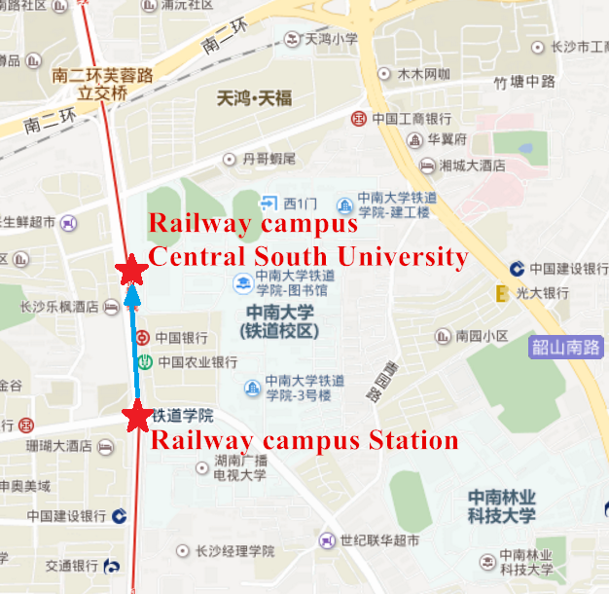
Railway campus, Central South University

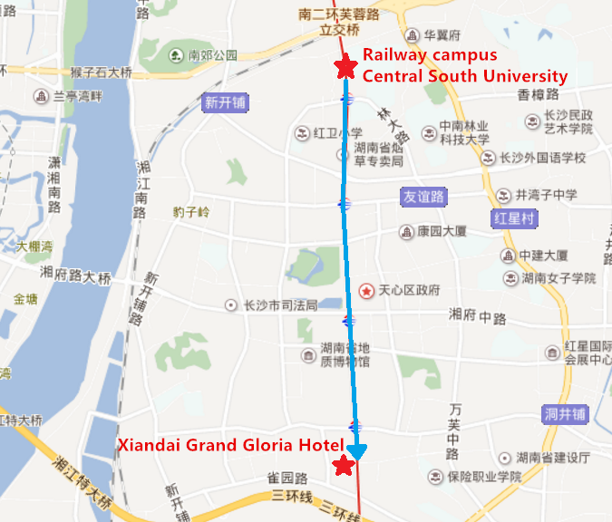
Xiandai Grand Gloria Hotel

Public transportation:

*The departing time is for reference only. It shall be in accordance with the actual travel itinerary of individuals.
*具体发车时间以实际乘坐为准
*Recommend Travel Alternatives
*推荐路线
1. Please buy your tickets at domestic flight window, in Beijing Capital International Airport.
国内转机：请在北京首都国际机场的国内航班售票窗口购买相应的机票。
- Long-distance Coaches: The airport bus Civil Aviation Hotel line will depart from the Changsha Huanghua International Airport to the Civil Aviation Hotel Station, and then change line 107 to Railway Campus Station. Total Ticket Price: 4 RMB. Travel time: 1 hour and 45 min.
长途客车：机场大巴将从长沙黄花国际机场出发到民航酒店站，然后换乘107号线到铁道学院站。票价：4元人民币。行程时间：1小时45分钟。
Taxis cost about 65 RMB from Changsha Huanghua International Airport to the conference venue): Xiandai Grand Gloria Hotel, 22 South Shaoshan Road, Changsha.

